Geometry: Unit 11, Lesson H1

- What is a regular polygon with $3$ sides?

Equilateral triangle

- What is a piece of the circumference of a circle?

Arc

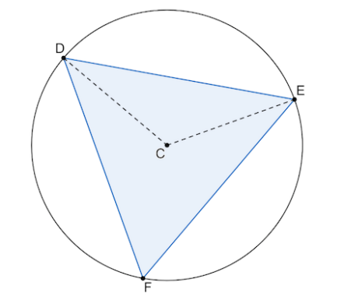
- Triangle $DEF$ inscribed in a circle with center, $C$, is shown. Given $∠DCE$ is a central angle and $m∠DCE=120°$, what is the measure of $\hat{DE}$?

$$m\hat{DE}=120°$$

